February 9-13, 2026
CS 800: Recursive Language Models

Measuring context rot
- Context Rot: How Increasing Input Tokens Impacts LLM Performance | Chroma Research
  - Needle-Question Similarity
    - Q: What is the magic number? vs. I’m looking for a special number.
    - A: The magic number is 126457.
  - Distractor Impact Analysis
    - Are there similar text/words in the context
  - Needle-Haystack Similarity
    - What is the document talking about in general? (does not affect performance much)
  - Haystack Structure (Coherent vs Shuffled)
    - Would the performance be affected if the sentences/paragraphs are shuffled? (needle locations stays the same, shuffled documents perform better)
  - When does context rot happen? - Momo
  - chroma-core/context-rot: This repository contains the toolkit for replicating results from our technical report.
  - Additional questions:
    - What if we have more than one needle?
    - What about combining “needles”? One example could be: There are two magic numbers in this document. Return the sum of the magic numbers.
- langchain-ai/how_to_fix_your_context
- How Long Contexts Fail
- How to Fix Your Context
- Lost in the Middle: How Language Models Use Long Contexts - ACL Anthology
- ETHIC: Evaluating Large Language Models on Long-Context Tasks with High Information Coverage - ACL Anthology
- TAIL: A Toolkit for Automatic and Realistic Long-Context Large Language Model Evaluation - ACL Anthology
- Evaluation of Large Language Models: Review of Metrics, Applications, and Methodologies
- Challenging LLMs Beyond Information Retrieval: Reasoning Degradation with Long Context Windows
- Context Degradation in LLMs
- Evaluating Long Context (Reasoning) Ability | wh
- Beyond a Million Tokens: Benchmarking and Enhancing Long-Term Memory in LLMs | OpenReview
- [2512.04307] Evaluating Long-Context Reasoning in LLM-Based WebAgents
- [2404.06654] RULER: What's the Real Context Size of Your Long-Context Language Models?

MVP of the Architecture
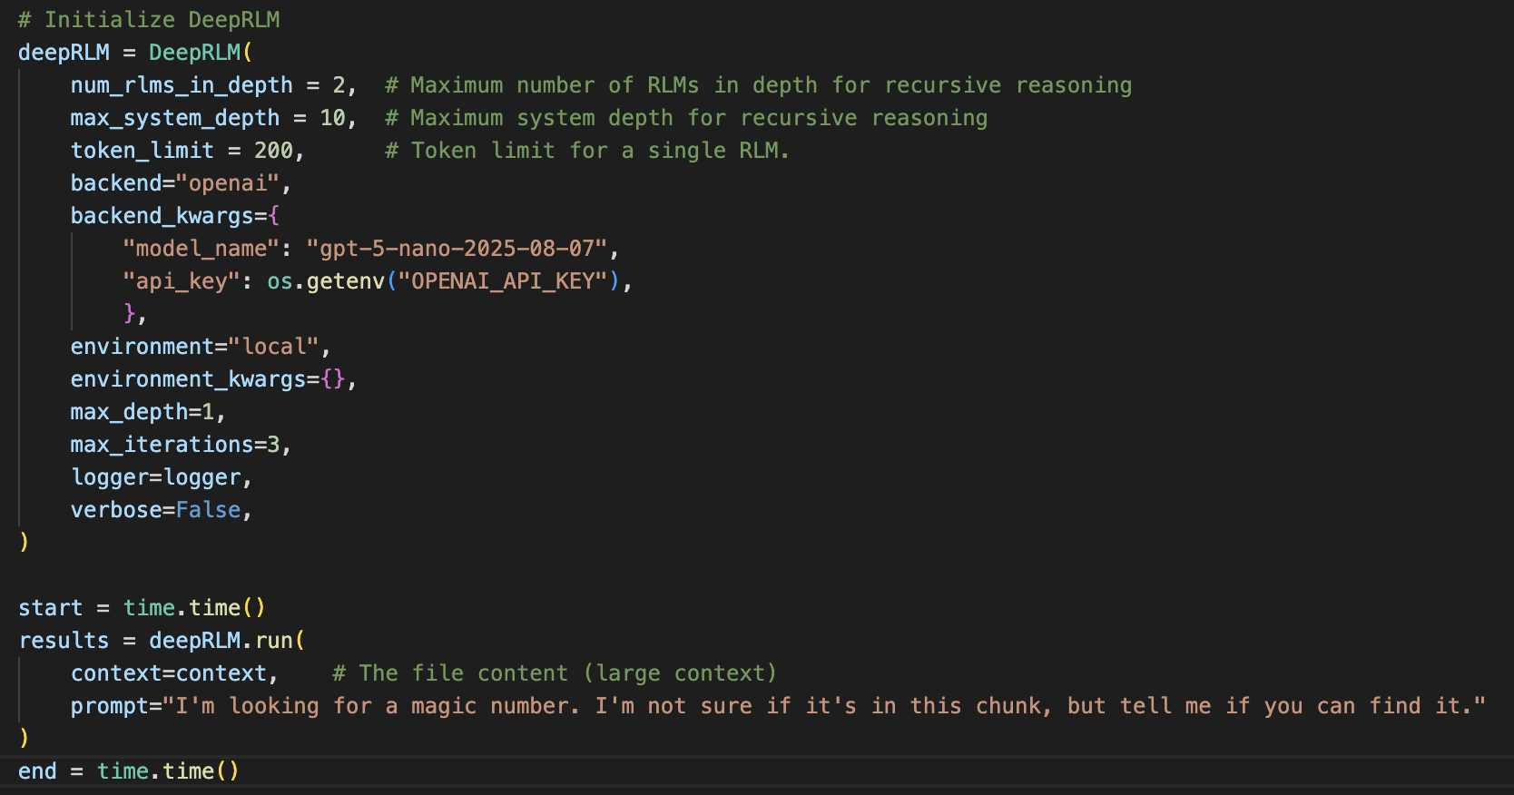
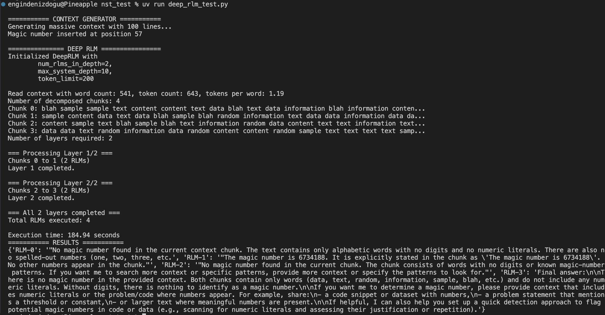
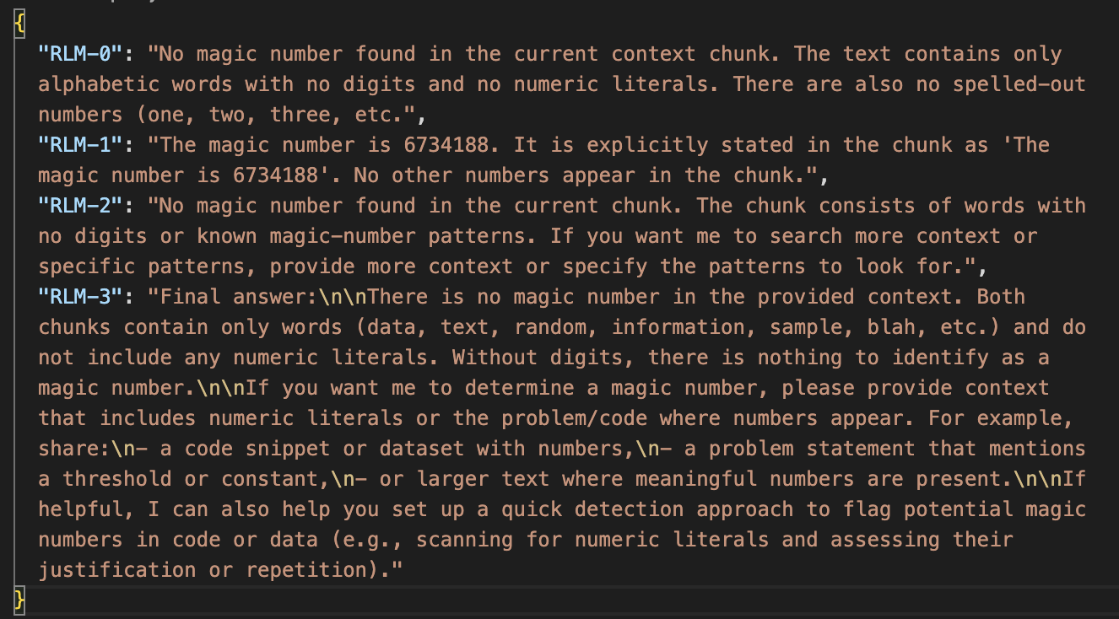
Todo: Figure out why the last RLM returns a longer answer (Is there some sort of leak? It seems like the last RLM is referring to the entire document).

Additional Readings - RLMs
- The Potential of RLMs
- mit-oasys/rlm-qwen3-8b-v0.1 · Hugging Face

Previous Discussions
- Current codebase does not implement working with multiple depths. Even if we set max_depth=5, it has no effect. Code only runs within depth=1.
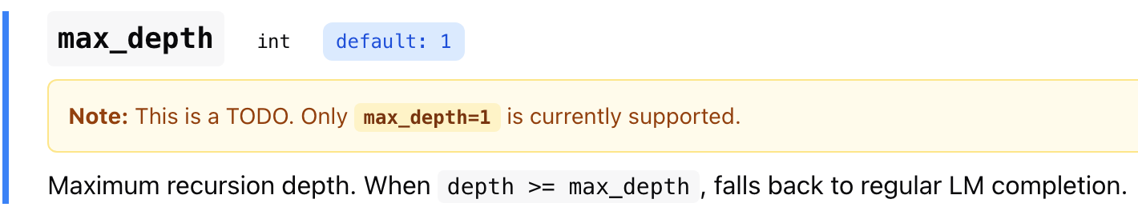
- Even if we implement more depths into the current repo, how would they run:
  - Parallel (like an agent council) OR
  - Sequentially (depth 2 is only invoked if depth 1 cannot find the answer)
- If their initial plan was to run them sequentially, what’s the advantage of calling multiple depths vs. single depth with more iterations:
  - Example: max_depth = 3, max_iterations = 30 vs. max depth = 1, max_iterations = 90
- We can combine RLMs with task decomposition like the github.com/sentient-agi/ROMA architecture. Our difference: context off-loading using RLMs. ROMA uses an external agent to decide if given task is “atomic” or not.
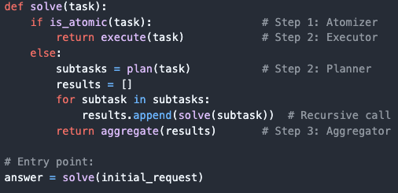

- Proposal:
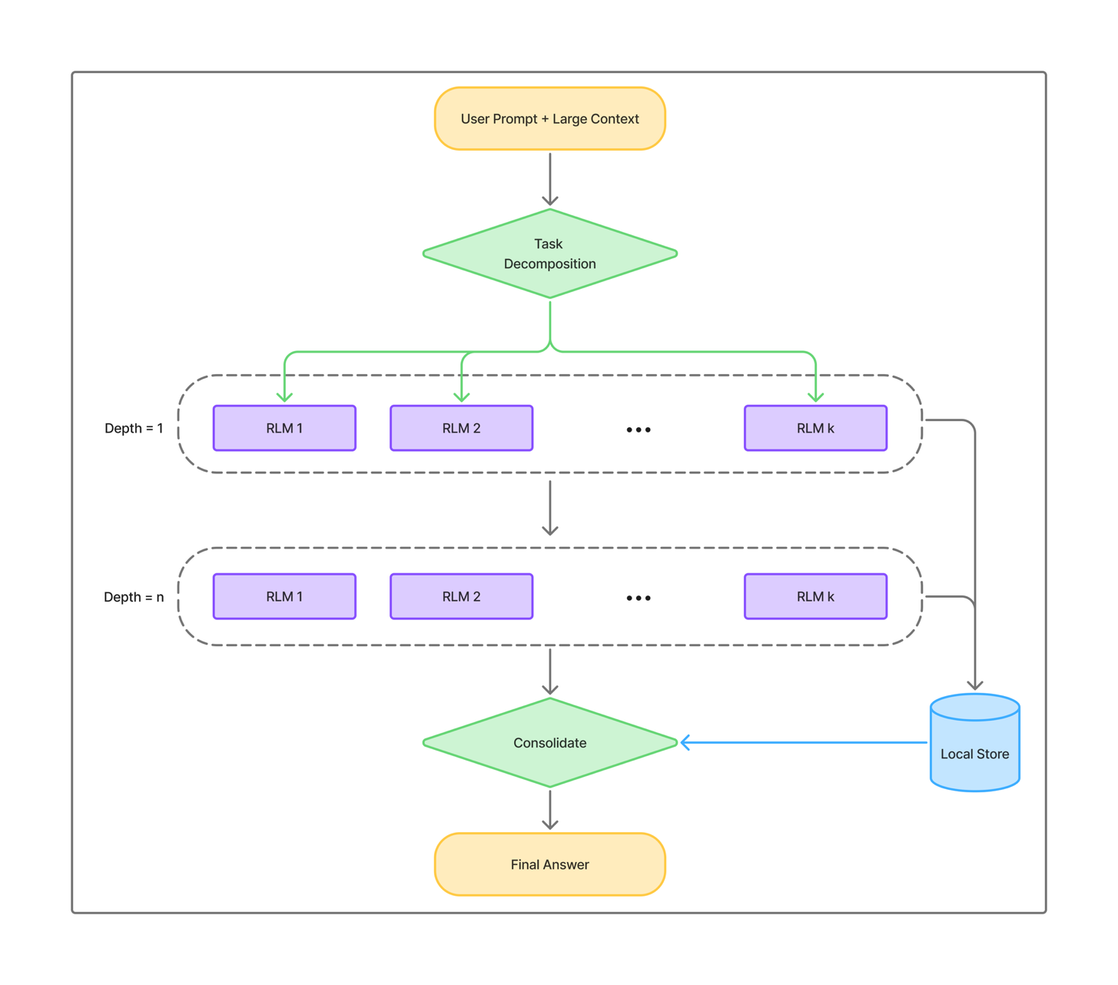
- What this improves/solves:
  - Handle even larger contexts (“RLMs can scale to the 10M+ token regime”)
  - Instead of trying to load the input at once, divide it into sub-RLMs. Limit the number of RLMs in each layer so that ‘depth’ acts as an early stopping mechanism. If you find the answer at level 1, stop.
  - Store results so that recursive calls are faster and cheaper
- LangChain’s DeepAgents: https://docs.langchain.com/oss/python/deepagents/long-term-memory. Use the Deep Agents SDK when you want to build agents that can:
  - Handle complex, multi-step tasks that require planning and decomposition
  - Manage large amounts of context through file system tools (e.g. summarizing web search results)
  - However, cannot handle large input context (e.g. if the input has 10M+ tokens)
  - Delegate work to specialized subagents for context isolation
  - Persist memory across conversations and threads

- Caching: We did not optimize our implementation of RLMs for speed, meaning each recursive LM call is both blocking and does not take advantage of any kind of prefix caching.
- Currently only “max_depth=1” is supported. That's why the diagram does not circle back for another RLM instantiation. What's the advantage of having depth >1 compared to increasing “max_iterations”? What’s the difference compared to ROMA? Limitations of systems like ROMA are mentioned in the paper: “By treating the prompt as an object in the external environment, this simple design of RLMs tackles a foundational limitation in the many prior approaches (Anthropic, 2025; Sentient, 2025; Schroeder et al., 2025; Sun et al., 2025), which focus on recursive decomposition of the tasks but cannot allow their input to scale beyond the context window of the underlying LLM.”
- Learned Recursive Decomposition Strategies: Current RLMs rely on the LLM's ability to programmatically manage context, but you could train models specifically on optimal decomposition strategies through RL. Research question: Can we learn task-specific or general-purpose decomposition policies that outperform ad-hoc programmatic approaches?

